**Company Data Storage Requirements**

The company is organized into branches. Each branch has a unique number, a name, and a particular employee who manages it.

The company makes it’s money by selling to clients. Each client has a name and a unique number to identify it.

The foundation of the company is it’s employees. Each employee has a name, birthday, sex, salary and a unique number.

An employee can work for one branch at a time, and each branch will be managed by one of the employees that work there. We’ll also want to keep track of when the current manager started as manager.

An employee can act as a supervisor for other employees at the branch, an employee may also act as the supervisor for employees at other branches. An employee can have at most one supervisor.

A branch may handle a number of clients, with each client having a name and a unique number to identify it. A single client may only be handled by one branch at a time.

Employees can work with clients controlled by their branch to sell them stuff. If nescessary multiple employees can work with the same client. We’ll want to keep track of how many dollars worth of stuff each employee sells to each client they work with.

Many branches will need to work with suppliers to buy inventory. For each supplier we’ll keep track of their name and the type of product they’re selling the branch. A single supplier may supply products to multiple branches.

**Er Diagram Mapping**

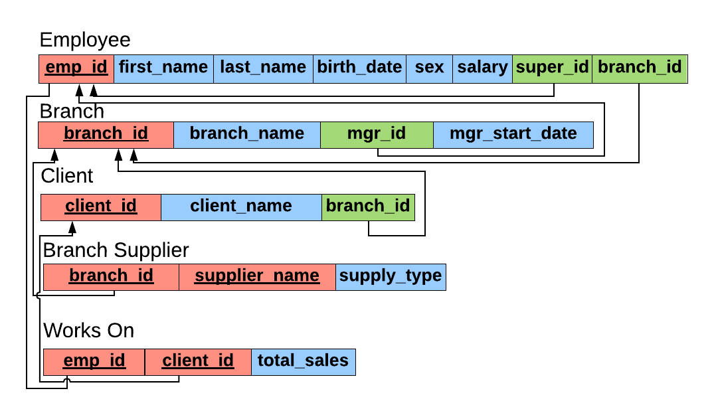

**Queries:**

CREATE TABLE employee (

emp_id INT PRIMARY KEY,

first_name VARCHAR (40),

last_name VARCHAR (40),

birth_date DATE,

sex VARCHAR(1),

salary INT,

super_id INT,

branch_id INT

);

CREATE TABLE branch (

branch_id INT PRIMARY KEY,

branch_name VARCHAR (40),

mgr_id INT,

mgr_start_date DATE,

FOREIGN KEY (mgr_id) REFERENCES employee(emp_id) ON DELETE SET NULL

);

ALTER TABLE employee

ADD FOREIGN KEY(branch_id)

REFERENCES branch(branch_id)

ON DELETE SET NULL;

ALTER TABLE employee

ADD FOREIGN KEY (super_id)

REFERENCES employee(emp_id)

ON DELETE SET NULL;

CREATE TABLE client (

client_id INT PRIMARY KEY,

client_name VARCHAR (40),

branch_id INT,

FOREIGN KEY (branch_id) REFERENCES branch(branch_id) ON DELETE SET NULL

);

CREATE TABLE works_with (

emp_id INT,

client_id INT,

total_sales INT,

PRIMARY KEY (emp_id,client_id),

FOREIGN KEY (emp_id) REFERENCES employee(emp_id) ON DELETE CASCADE,

FOREIGN KEY (client_id) REFERENCES client(client_id) ON DELETE CASCADE

);

CREATE TABLE branch_supplier (

branch_id INT,

supplier_name VARCHAR(40),

supply_type VARCHAR(40),

PRIMARY KEY (branch_id,supplier_name),

FOREIGN KEY (branch_id) REFERENCES branch(branch_id) ON DELETE CASCADE

);

--INSERT CORPORATE BRANCH

INSERT INTO employee VALUES (100,'David','Wallace','1967-11-17','M',250000,NULL,NULL);

INSERT INTO branch VALUES (1,'Corporate',100,'2006-02-09');

UPDATE employee

SET branch_id=1

WHERE emp_id=100;

INSERT INTO employee VALUES (101, 'Jan', 'Levinson', '1961-05-11', 'F', 110000, 100, 1);

-- Scranton

INSERT INTO employee VALUES(102, 'Michael', 'Scott', '1964-03-15', 'M', 75000, 100, NULL);

INSERT INTO branch VALUES(2, 'Scranton', 102, '1992-04-06');

UPDATE employee

SET branch_id = 2

WHERE emp_id = 102;

INSERT INTO employee VALUES(103, 'Angela', 'Martin', '1971-06-25', 'F', 63000, 102, 2);

INSERT INTO employee VALUES(104, 'Kelly', 'Kapoor', '1980-02-05', 'F', 55000, 102, 2);

INSERT INTO employee VALUES(105, 'Stanley', 'Hudson', '1958-02-19', 'M', 69000, 102, 2);

-- Stamford

INSERT INTO employee VALUES(106, 'Josh', 'Porter', '1969-09-05', 'M', 78000, 100, NULL);

INSERT INTO branch VALUES(3, 'Stamford', 106, '1998-02-13');

UPDATE employee

SET branch_id = 3

WHERE emp_id = 106;

INSERT INTO employee VALUES(107, 'Andy', 'Bernard', '1973-07-22', 'M', 65000, 106, 3);

INSERT INTO employee VALUES(108, 'Jim', 'Halpert', '1978-10-01', 'M', 71000, 106, 3);

-- BRANCH SUPPLIER

INSERT INTO branch_supplier VALUES(2, 'Hammer Mill', 'Paper');

INSERT INTO branch_supplier VALUES(2, 'Uni-ball', 'Writing Utensils');

INSERT INTO branch_supplier VALUES(3, 'Patriot Paper', 'Paper');

INSERT INTO branch_supplier VALUES(2, 'J.T. Forms & Labels', 'Custom Forms');

INSERT INTO branch_supplier VALUES(3, 'Uni-ball', 'Writing Utensils');

INSERT INTO branch_supplier VALUES(3, 'Hammer Mill', 'Paper');

INSERT INTO branch_supplier VALUES(3, 'Stamford Lables', 'Custom Forms');

-- CLIENT

INSERT INTO client VALUES(400, 'Dunmore Highschool', 2);

INSERT INTO client VALUES(401, 'Lackawana Country', 2);

INSERT INTO client VALUES(402, 'FedEx', 3);

INSERT INTO client VALUES(403, 'John Daly Law, LLC', 3);

INSERT INTO client VALUES(404, 'Scranton Whitepages', 2);

INSERT INTO client VALUES(405, 'Times Newspaper', 3);

INSERT INTO client VALUES(406, 'FedEx', 2);

-- WORKS_WITH

INSERT INTO works_with VALUES(105, 400, 55000);

INSERT INTO works_with VALUES(102, 401, 267000);

INSERT INTO works_with VALUES(108, 402, 22500);

INSERT INTO works_with VALUES(107, 403, 5000);

INSERT INTO works_with VALUES(108, 403, 12000);

INSERT INTO works_with VALUES(105, 404, 33000);

INSERT INTO works_with VALUES(107, 405, 26000);

INSERT INTO works_with VALUES(102, 406, 15000);

INSERT INTO works_with VALUES(105, 406, 130000);

SELECT * FROM employee;